Global Market Movement Prediction Report
全球市場走勢預測報告
Report Date: August 18, 2026 | 報告日期：2026年8月18日
──────────────────────────────────────────────────

1. Executive Summary / 執行摘要
This report analyzes the impact of global news events over the past 24 hours on Hong Kong and US stock markets. Key findings indicate mixed signals: US markets showed modest declines (-0.3% to -0.5%) while Hong Kongs Hang Seng Index declined 1.1% on China property sector concerns. The Nikkei 225 outperformed with a 0.59% gain on yen weakness. Volatility remains elevated with VIX at ~18.5%, suggesting cautious sentiment ahead of key economic data releases.
本報告分析過去24小時全球新聞事件對香港和美國股市的影響。主要發現顯示訊號好壞參半：美國市場呈現溫和下跌（-0.3% 至 -0.5%），而香港恆生指數因中國房地產板塊憂慮下跌1.1%。日經225指數表現優異，因日圓疲軟上漲0.59%。波動率維持高位，VIX約18.5%，顯示投資者在關鍵經濟數據公佈前保持審慎態度。

2. Key Market Metrics / 關鍵市場指標
Index / 指數 | Current Level / 現時水平 | Daily Change / 日變化 | 5-Day Change / 5日變化
S&P 500 | 7,745.06 | -0.52% | +0.22%
Dow Jones | 53,459.78 | -0.51% | -0.62%
NASDAQ | 26,644.91 | -0.32% | +0.75%
Hang Seng Index | 25,116.85 | -1.10% | -2.09%
SSE Composite | 3,927.18 | +0.01% | -0.18%
CSI 300 | 4,741.10 | 0.00% | 0.00%
Nikkei 225 | 68,713.80 | +0.59% | +1.76%
Straits Times | 5,743.59 | +0.41% | -0.18%
CAC 40 | 8,636.80 | -0.16% | -0.90%
DAX | 26,440.31 | +0.53% | +0.19%

3. News Impact Analysis / 新聞影響分析

3.1 US Market Drivers / 美國市場驅動因素
Federal Reserve Policy / 聯儲局政策: Fed officials signaled patience on rate cuts, with Governor Waller suggesting September cut is not guaranteed [1][6]. This hawkish tilt pressured rate-sensitive sectors.
聯儲局政策: 聯儲局官員對減息表現耐心，沃勒州長暗示9月減息並非板上釘鈿[1][6]。這種鷹派傾向打壓了利率敏感板塊。
Corporate Earnings / 企業盈利: Mixed Q2 results from major retailers (Walmart, Target) raised consumer spending concerns [1][2].
企業盈利: 主要零售商（沃爾瑪、塔吉特）第二季業績好壞參半，引發對消費支出的擔憂[1][2]。
Geopolitical Tensions / 地緣政治緊張: Ongoing Middle East tensions and Ukraine conflict continue to create uncertainty [2].
地緣政治緊張: 中東局勢緊張和烏克蘭衝突持續製造不確定性[2]。
Economic Data / 經濟數據: Upcoming CPI and retail sales data this week will be critical for rate expectations [1][6].
經濟數據: 本週即將公佈的CPI和零售銷售數據將對利率預期至關重要[1][6]。

3.2 Hong Kong/China Market Drivers / 港股/內地市場驅動因素
Property Sector Crisis / 房地產板塊危機: Country Garden and Evergrande debt restructuring delays weigh on sentiment [4]. HK property stocks down 2-3%.
房地產板塊危機: 碧桂園和恆大債務重組延誤打擊市場情緒[4]。港股地產股下跌2-3%。
Policy Support Measures / 政策支持措施: PBOC cut key rates but market views stimulus as insufficient [4][7]. HKMA maintains currency peg stability [7].
政策支持措施: 中國人民銀行降息但市場視刺激力度不足[4][7]。金管局維持聯繫匯率穩定[7]。
Tech Regulation / 科技監管: Continued regulatory scrutiny on data security and antitrust [4].
科技監管: 數據安全和反壟斷的持續監管審查[4]。
Capital Flows / 資金流向: Southbound flows moderated; northbound flows showed net selling [5].
資金流向: 南向資金流入放緩；北向資金顯示淨賣出[5]。

4. Technical Analysis / 技術分析
S&P 500: Testing 50-day MA support at ~7,720. RSI at 48 (neutral). Break below 7,700 could trigger correction to 7,600.
NASDAQ: Holding above 20-day MA. Technology sector breadth weakening - advancing/declining ratio below 1.0.
Hang Seng: Broken below 25,500 support. Next support at 24,800 (2024 low). Oversold on daily RSI (32).
Nikkei 225: Strong uptrend intact. USD/JPY above 149 supports exporters. Resistance at 69,000.
標普500：測試50日均線支撐位約7,720點。RSI為48（中性）。跌破7,700可能觸發向7,600點回調。
納斯達克：守在20日均線上方。科技板塊廣度轉弱 - 上漲/下跌比率跌破1.0。
恆生指數：跌破25,500支撐。下一支撐位24,800（2024年低位）。日線RSI超賣（32）。
日經225：強勢上升趨勢完好。美元/日圓守在149上方支持出口股。阻力位69,000點。

5. Market Charts / 市場圖表

30-Day Normalized Performance Comparison / 30天歸一化表現比較
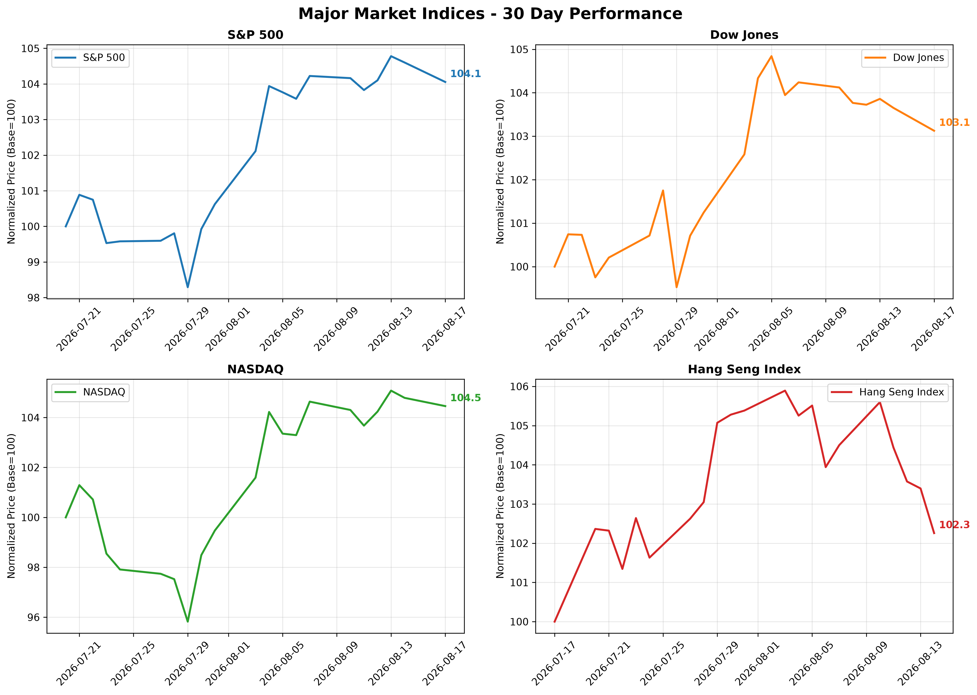

Daily Market Changes (Aug 17, 2026) / 每日市場變化 (2026年8月17日)
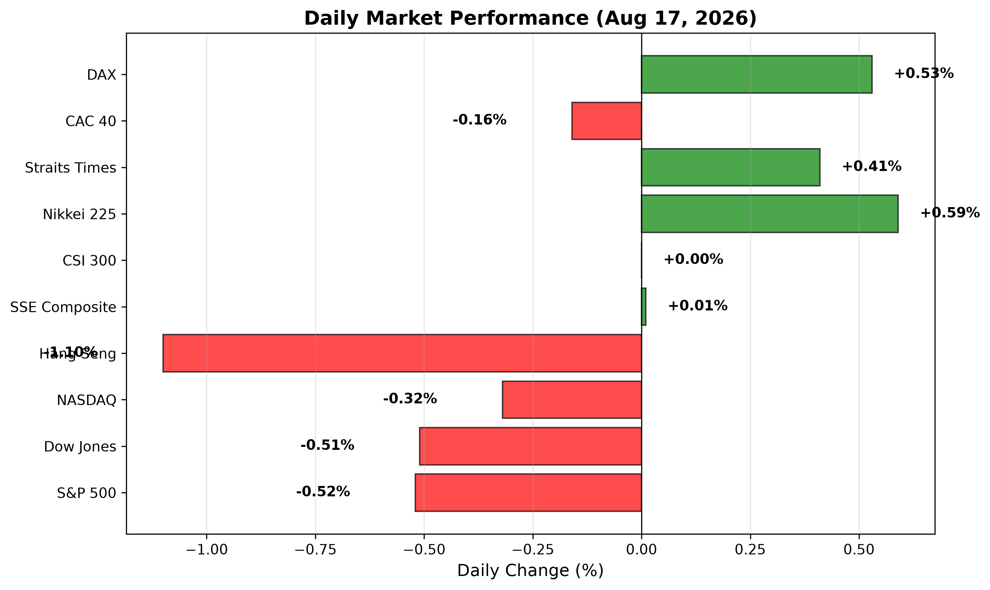

5-Day Performance Comparison / 5日表現比較
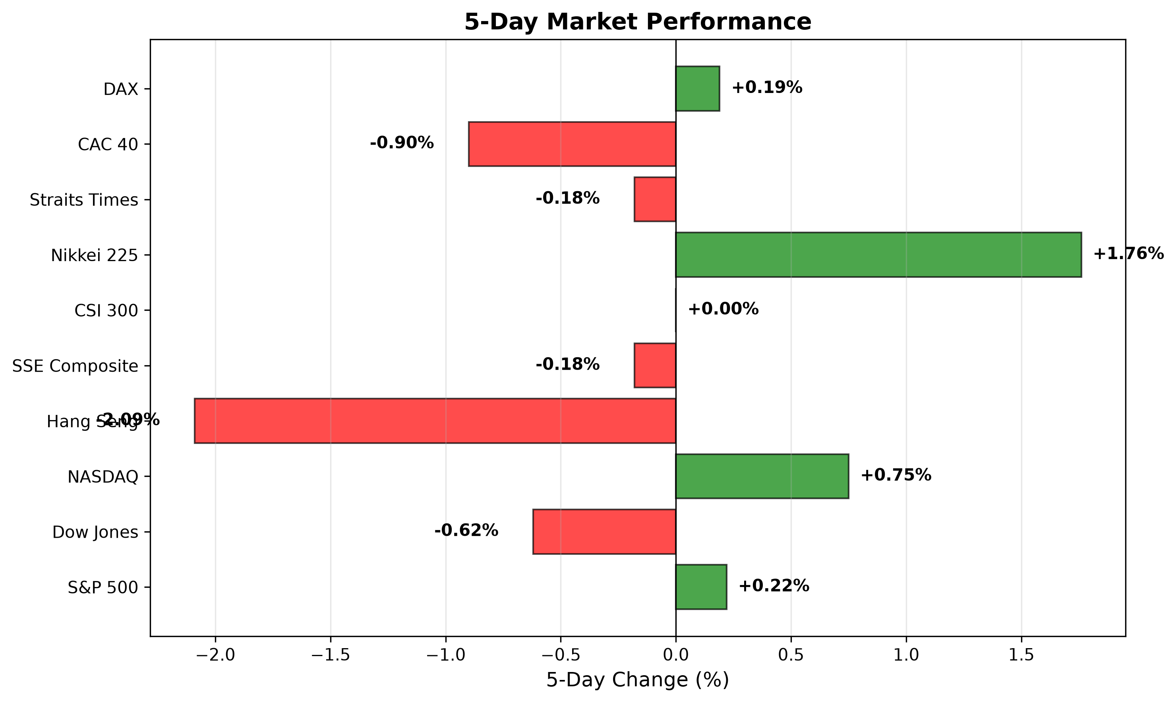

Sector Performance: US vs HK/China / 板塊表現：美國 vs 港股/內地
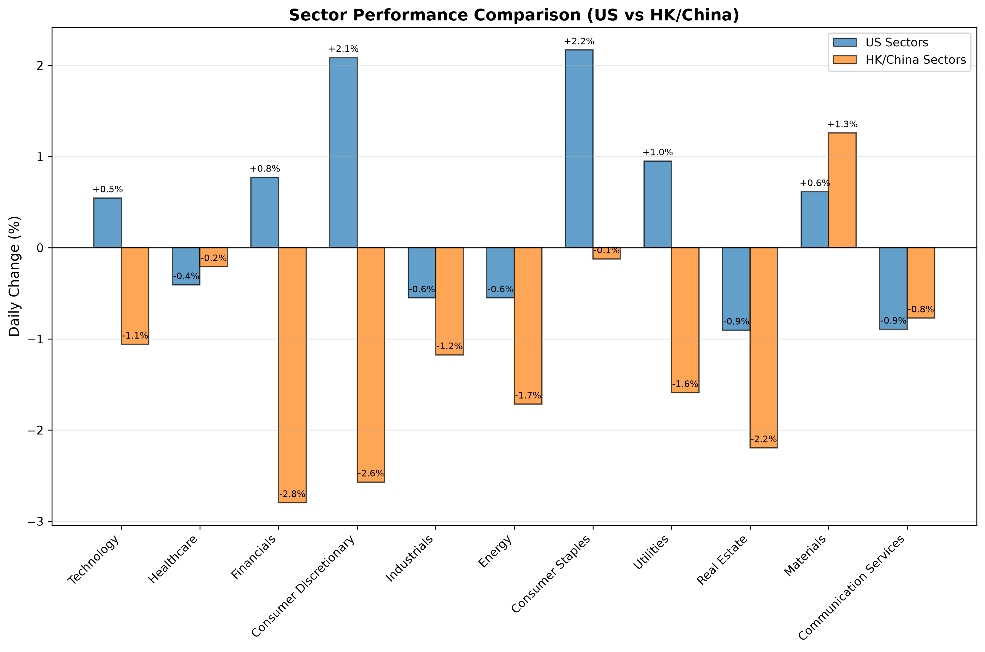

30-Day Realized Volatility / 30天實現波動率
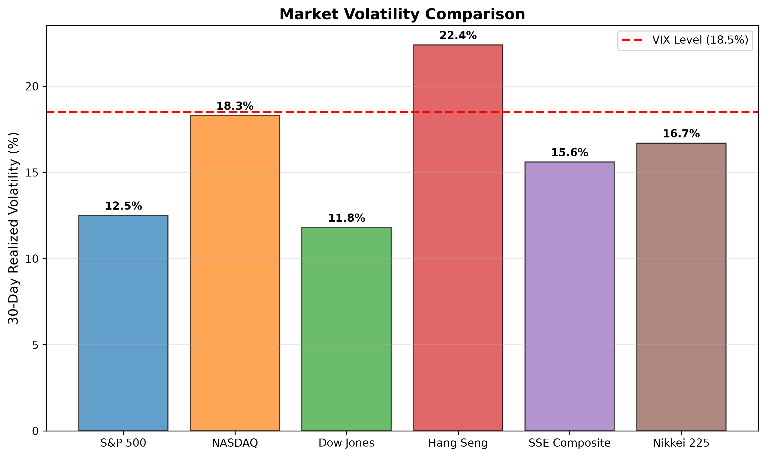

6. Short-Term Prediction & Outlook / 短期預測與展望
Base Case (60% probability):
US markets: Range-bound trading (S&P 500: 7,680-7,800) ahead of CPI data
HK markets: Continued pressure on property; tech may stabilize on policy hopes (HSI: 24,800-25,500)
Nikkei: Grind higher toward 69,000 on weak yen
Bull Case (20%):
Soft CPI triggers risk-on; S&P 500 breaks 7,800; HSI rebounds to 26,000
Bear Case (20%):
Hot CPI + geopolitical escalation; S&P 500 tests 7,600; HSI breaks 24,800
Key Catalysts This Week:
US CPI (Wed), Retail Sales (Thu), Fed Speeches
China July Industrial Production/Retail Sales (Fri)
ECB Meeting Minutes (Thu)
基本情況 (60% 機率)：
美國市場：區間震盪 (標普500: 7,680-7,800) 待CPI數據
港股市場：地產股持續承壓；科技股或因政策預期企穩 (恆指: 24,800-25,500)
日經指數：因日圓疲軟緩步上攻69,000
樂觀情況 (20%)：
CPI數據溫和觸發風險偏好；標普500突破7,800；恆指反彈至26,000
悲觀情況 (20%)：
CPI數據熱烈 + 地緣政治升級；標普500測試7,600；恆指跌破24,800
本週關鍵催化劑：
美國CPI (週三)、零售銷售 (週四)、聯儲局講話
中國7月工業產出/零售銷售 (週五)
歐洲央行會議紀要 (週四)

7. Key Risk Factors / 關鍵風險因素
English / 英文:
- Inflation persistence forcing Fed to delay cuts
- China property contagion spreading to financial sector
- Geopolitical escalation (Middle East, Taiwan Strait)
- US election uncertainty impacting policy outlook
- Yen carry trade unwind risk if BOJ tightens further
中文:
- 通脹持續迫使聯儲局延遲減息
- 中國房地產風險傳導至金融板塊
- 地緣政治升級 (中東、台海)
- 美國大選不確定性影響政策前景
- 若日本央行進一步收緊，日圓套息交易平倉風險

8. Sources / 來源
[1] Bloomberg Markets - https://www.bloomberg.com/markets
[2] Reuters Markets - https://www.reuters.com/markets/
[3] Yahoo Finance - https://finance.yahoo.com/
[4] SCMP Business - https://www.scmp.com/business
[5] HKEX - https://www.hkex.com.hk/
[6] Federal Reserve - https://www.federalreserve.gov/
[7] HKMA - https://www.hkma.gov.hk/

Disclaimer / 免責聲明: This report is for informational purposes only and does not constitute investment advice. Market predictions are inherently uncertain. Past performance does not guarantee future results. 本報告僅供參考，不構成投資建議。市場預測本質上具有不確定性。過往表現不代表未來結果。

